Driven Racing Oil™ DBR Diesel Break-In Oil
Huntersville, NC – Driven Racing Oil’s latest break-in oil, DBR, is designed for high-performance and turbocharged diesel engines.
DBR promotes proper surface mating during the critical break-in process and chemically assists with piston ring sealing, thanks to a proprietary anti-wear formulation that doesn’t rely on conventional friction modifiers. It also features a low detergent level that allows the “fast burn” ZDDP additive to adhere directly to all ferrous metal wear surfaces for maximum scuffing protection of flat tappet cams, bushing lifters, cam driven fuel pumps, turbocharger bearings and cylinder bores.
The conventional 15W-40 oil can be used in naturally aspirated and turbo diesel engines and is also safe for engines fitted with exhaust after treatment devices. It is good for dyno testing or up to 1,000 miles on the street, with no ZDDP or break-in additives required.
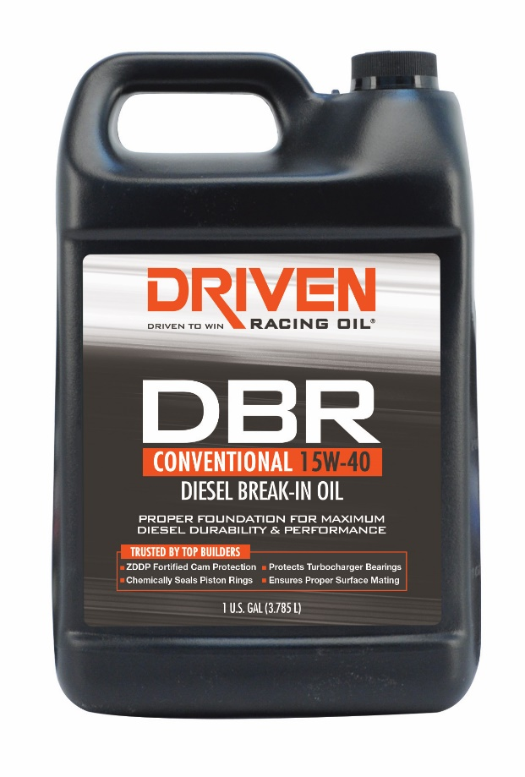
Part Numbers: #05308 (1 gal.) Price: $29.99
About Driven Racing Oil™
Driven Racing Oil™ utilizes cutting-edge lubricant technology and on-track research for maximum performance gains from all of its product offerings. Competition drives innovation, and Joe Gibbs Racing originally developed the Driven brand of oils to advance engine and driveline performance on the racetrack. From full-synthetic race oils to engine break-in oils and cleaners, Driven offers a wide range of race and street products that deliver performance, protection and value.

